
  - Ten Page Game Design document.

PC, rated PEGI 3
To be released on 17-11-2023
Contents
Design challenge 4
Gameplay 4
Game Pillars 4
Puzzle-solving 4
Locational mechanics 4
Stealth 5
Story 5
Storytelling 6
Audio communication with Earth 6
Non-testing chambers 6
Prototype rooms 6
Voyager 2 6
Human study room 6
Alien assembly room 6
Mind Crystal 6
Topography room 7
Alien robots 7
Audio design 7
Adaptive music 7
Music 7
Gravity mechanic 7
Sound effects 8
Unique selling points 8
Game flow 9
Platform 9
Controls 9
Genre 9
Setting 9
Game world 10
Mood 10
Theme 12
Main mechanics 12
Dynamics 12
Aesthetics 12
Similar products 12
Inspiration 12
Levels 13
Level 1: tutorial 13
Level 2: gravity 14
Level 3: electric/water 14
Level 4: illusion 14

Design challenge
Design a 3D first person puzzle-platformer game to enable players that want to be entertained to solve logical puzzles using varied game mechanics to complete objectives by traversing through different testing rooms and hallways.
Tag | Attribute
Form of solution | 3D first person puzzle platformer
Users | Players aged 10+
Context
Performed action | Move, jump, and interact with the environment
Target performance | Having fun using your brain

Gameplay
The Scout is a puzzle platformer game. The game is 3D as much of the inspiration was 3D as well. The Scout is linear, as a more complex level design requires a high increase in workload. The testing chambers are connected through maintenance rooms and hallways as seen in Figure 1. The testing chambers only have one entrance and exit. The player is unable to open the doors of the maintenance rooms / hallways, apart from the testing chamber doors. Apart from the main controls of the character, the game offers many different mechanics to keep the gameplay interesting and unique. While solving puzzles, the player must avoid being seen by security robots and cameras in the facility. When the player is spotted, …
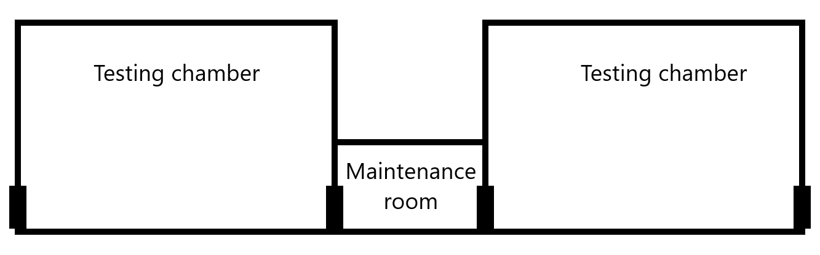
Figure 1 Base room layout

Game Pillars

Puzzle-solving
The player uses critical thinking combined with objects/environments presented to them to solve puzzles to proceed in the game. Every room offers different puzzles that keep the player thinking. The puzzles will be unique, so the player is always faced with something new, to avoid repetitive thinking.

Locational mechanics
Every distinct location in the game uses a different mechanic to solve the puzzle.

Stealth
The player must avoid security robots and cameras in the facility. If the play is seen, the robots attempt to kill the player. The vision of the robots / cameras will be visible so the player can move around them, like in Figure 2.
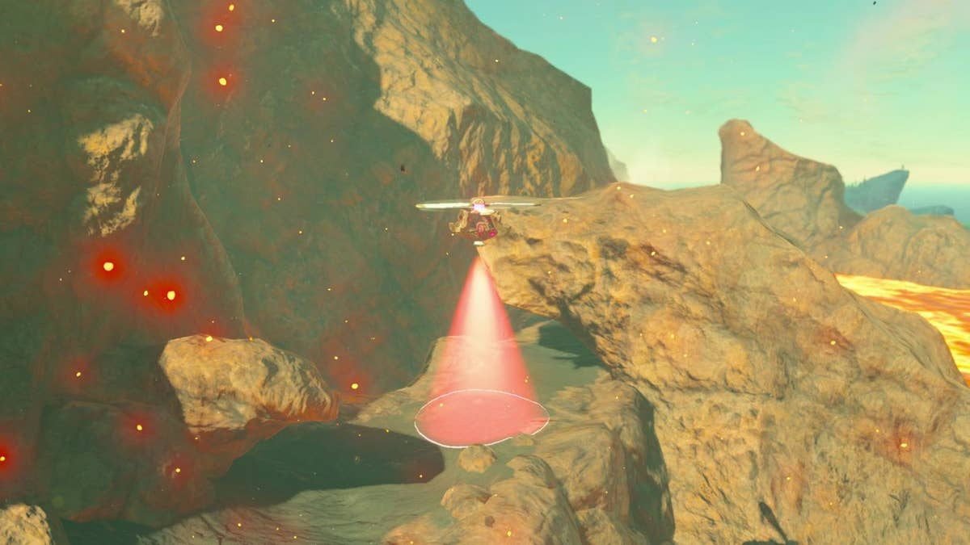
Figure 2 'Vision' cone from Zelda: Breath of the Wild

Story
An alien spaceship has arrived at Earth. The humans scanned the spaceship and found common objects across the ship, like buttons, platforms, and pressure plates. The scout, the player, must complete a training room containing the objects to learn how they work.
After completing the preparation, the scout is sent to infiltrate the alien scientific facility to learn as much as possible about their technology. To explore, the player must travel through testing chambers and hallways. Throughout the story, the player has an audio connection back to Earth to communicate what happens on the ship. The testing chambers are used by the aliens to research advanced technology by using test robots. Maintenance robots clean up the testing chambers after they are solved, allowing for faster testing, with the side effect of the player remaining undetected. The player must use the technology to solve the puzzles and go through the room. Throughout the rooms, the player learns that the facility contains blueprints for advanced machinery.
In the game, the player does not see any aliens, as they became digital minds through time. The aliens use physical robots to clean up and survey the test chambers. To allow different robots to work on the ship, the ship is fitted with a resizer that automatically resizes everything that goes through to the size of the spaceship, explaining why the player’s size is normal in comparison to the rooms and objects. As the aliens found out life, especially biological life, is very rare, they are interested in studying it.
The player traverses through several more test chambers to get to the blueprints. When the player retrieves the blueprints, they use an escape pod to return to Earth.

Storytelling

Audio communication with Earth
The scout has an audio communication line back to Earth. The player communicates with Earth when there are important events happening, such as exiting a testing chamber, explaining the technology to Earth. To keep the eeriness and mystery of the levels, this communication is kept to a minimum.

Non-testing chambers
In between testing rooms, there are maintenance rooms and hallways, which can be filled with lore components. To keep the player motivated to progress through the testing chambers, the rooms in between can reveal grand story points.

Prototype rooms
The aliens have rooms containing blueprints for the technology tested in the testing chambers. The player

Voyager 2
A room containing the Voyager 2, with monitors which calculated the trajectory. This shows how the aliens found the humans.

Human study room
As the aliens do not fully understand the human biology yet, they recreated human objects to study them. Works of art, diagrams containing human anatomy, images of animals on Earth, and small replicas of buildings.

Alien assembly room
Room where physical bodies are made forx aliens (physical bodies are inspired by humans).

Mind Crystal
This is the most important room to the aliens. This is the room where the most influential aliens are stored. They are so critical to the alien civilization that they have left behind their physical form and stored their consciousness within the Mind Crystal. Apparatuses connected to the Mind Crystal allow minds to be transferred to physical bodies.
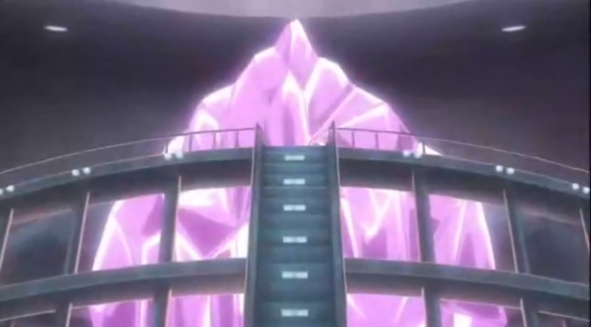
Figure 3 Mind Crystal

Topography room
A room containing a holographic map of the galaxy, showing many galaxy clusters, a marker for the aliens’ home planet, a marker where they found the Voyager 2, and the way the aliens took to Earth. An example for a map is shown in Figure 4.
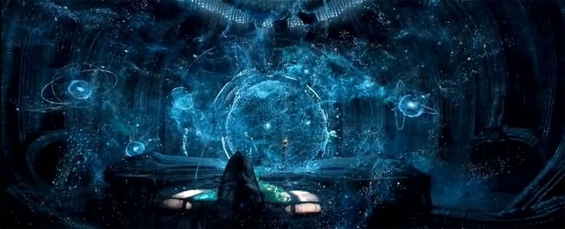
Figure 4 Example of a galaxy map

Alien robots
Some of the robots can be seen moving throughout the facility.
Maintenance robots make sure the testing chambers are ‘reset’ for the next test subject. They keep the facility running and move boxes etc. back to their original positions. The maintenance robots come in different sizes, as some objects are larger than others. Sometimes, robots can be seen moving out of frame just as the player looks.
Surveillance robots patrol testing chambers, maintenance rooms, and hallways, looking for intruders. They signal that the player is not wanted aboard the vessel. Should the player get spotted, the robots attack the player ruthlessly, as the aliens’ security protocols are way more advanced in comparison to the humans.
Testing robots are used for the testing chambers. They occasionally show how certain mechanics work.

Audio design

Adaptive music
Since the game has separated mechanics and elements that could define states of a level (gravity being in specific directions, electric contraptions being powered etc.), the game is suitable for adaptive music.

Music
Like in the Metroid series and SOMA, the music will have low bass tunes to amplify the eeriness of the mood of the game. To prevent the player experiencing resonance, the pitch of the tunes will gradually change. The low tunes are held for a long period, to add to the calmness of the game.

Gravity mechanic
The gravity in the testing chamber can go in 6 directions. In Portal 2, the music fully changes.

Sound effects
Category | Name
Ambience | Robots walking in the distance / other rooms
 | Flying security robot
 | Metallic maintenance sounds
 | Mechanical sounds (pistons retracting / extending)
 | Ambience for spaceship
Character | Footsteps
 | Jumping
 | Landing
Interactables | Box collisions
 | Heavy box sliding
 | Camera spotting the player
 | Alarm going off after player is spotted
 | Pressure plate being activated
 | Pressure plate being deactivated
 | Button being pressed
 | Jump pad being activated
 | Jump pad being deactivated
 | Jump pad launching object / player
 | Bridge extending
 | Bridge retracting
 | Illusion: color changing
 | Illusion: objects appearing
 | Illusion: objects disappearing
 | Door opening
 | Door closing
UI | Button clicks
 | Saving?

Unique selling points
- Unique mechanics
- Different settings

Game flow
The game’s core loop consists of two parts: the action and expansion, visualized in Figure 3.

Figure 5 Modified game core loop inspired by Dejan Zuza
The main action of the game is solving the puzzles in the test chambers.
The reward is the same as the expansion, as solving the puzzles unlocks the way forward.

Platform
The game will be made for Windows, PC, as this is the easiest for development. Should there be spare time, the team can expand the project to make it accessible for more systems.

Controls
Control | Action
WASD | Move
Space | Jump
Left click | Interact
Mouse movement | Look around

Genre
The player is constantly traveling through new rooms with different themes. The rooms all have puzzles to solve to unlock the way forward and have platforms for the player to traverse the room itself. Therefore, the game’s genre consists of adventure, puzzle, and platforming.

Setting
The game takes place on an alien scientific facility like Metroid Prime 3: Corruption, as seen in Figure 4. The facility contains big rooms, where the aliens are experimenting with their technology using test chambers. The technology is tested in different environments, meaning each test chamber has its own setting, as described in Levels.
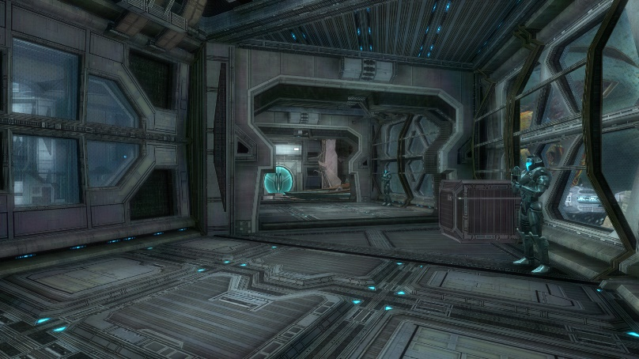
Figure 6 Metroid Prime 3: Corruption

Game world
The player is limited to interact with the objects the game allows them to interact with. The player needs feedback from the game, and therefore the interaction with the objects, to figure out how it works, which increases the workload a lot.

Mood
As the game is focused on puzzles and platforming, the mood is mainly calm yet eerie. Players take various amounts of time to figure out a solution to the puzzles or to make it to a platform. The team decided not to add time pressure to prevent frustration. A calm mood will give the player more patience when solving puzzles or platforming. The game’s setting is an alien scientific facility which adds eeriness to the mood. The facility’s corridors and maintenance rooms are scientific and industrial, giving the environment a mechanical aspect. As the mechanics are highly advanced compared to human technology, the mood must also be technological.
In all rooms, there are sci fi noises to communicate the high-tech surroundings. For this reason, the maintenance rooms and corridors outside of the testing chambers will also have neon lighting as seen in Figure 5, Subnautica, and Figure 6 of Horizon Zero Dawn.
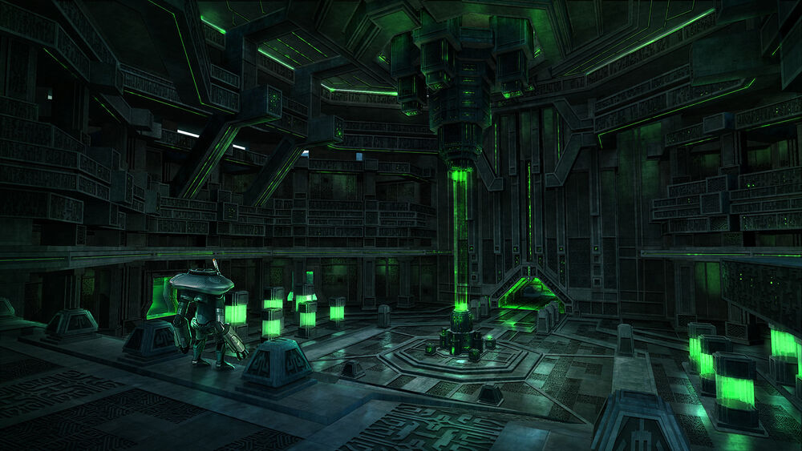
Figure 7 Subnautica
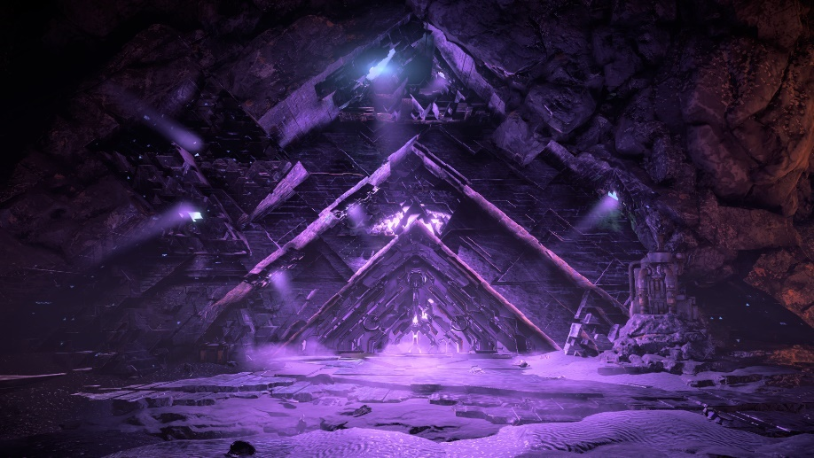
Figure 8 Horizon Zero Dawn
The maintenance rooms have straight, rectangular shaped objects to make it look mechanical, like Metroid Prime 3: Corruption in Figure 7.
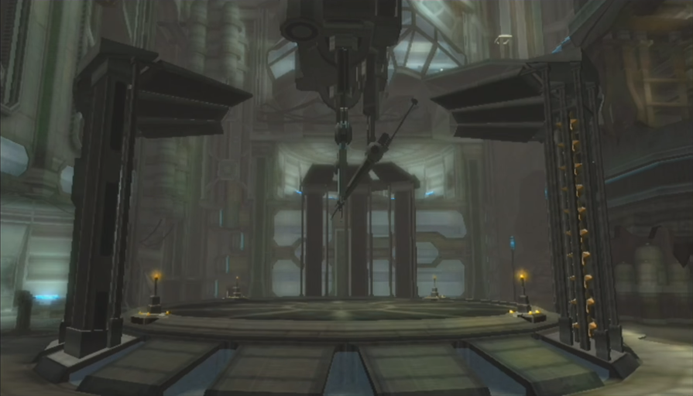
Figure 9 Metroid Prime 3: Corruption
The hallways and maintenance rooms have dark colors like the Nostromo map from Dead by Daylight, seen in Figure 7, which creates an eerie feeling in the game. The music in the whole game is quiet and calm, contributing to an eerie mood.
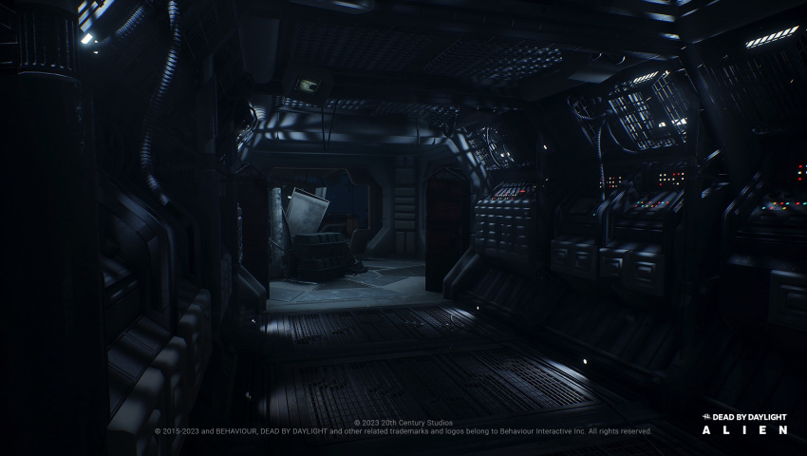
Figure 10 Nostromo map from Dead by Daylight

Theme
The player is set out to learn about the aliens and their technology, which turns into a quest to find blueprints of advanced machinery. The player is constantly moving forward, traversing room after room. The theme is therefore exploration.

Main mechanics
Aside from the room specific mechanics, there are a few set mechanics that are consistent throughout the whole game.
- Testing chambers have one door to enter and one door to exit.
- In between testing chambers, there is always a maintenance room or corridor.
- The player can move.
- The player can jump.
- The player can interact with certain objects. The result of the interaction depends on the object.
- In testing chambers, cameras and robots are surveilling the area. If the player is spotted, they die and must restart the room.

Dynamics
Players can mess around with the room’s mechanics to figure out how it works exactly.

Aesthetics
As the player does not know what will happen after the room they’re in, the kind of fun that fits the game most is discovery.

Similar products
Portal 2.

Inspiration
The overall idea of the game came from Portal, a puzzle platformer.

Levels

Level 1: tutorial
Mechanic: Object interaction, carrying/pushing objects, buttons, pressure plates, jump pads
Objective: Pass your training
Obstacles: Doors and cameras
Setting: Recreated testing chamber
Mood: Sterile, featureless
Theme: Learning, preparation
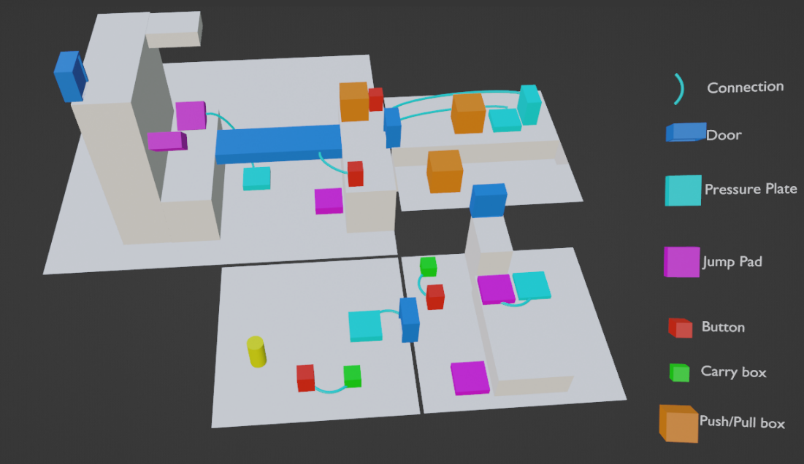
Figure 11 Tutorial area layout draft
To teach the player the basic mechanics of the game, the player is given a mechanic to puzzle with in each section of the tutorial. Starting with the easiest: a button, light box, and a pressure plate, followed by jump pads and then heavy boxes. In the last room, the puzzle elements are combined.
The environment of the training area is simplistic, as it is recreated from a scan of the alien spaceship, which results in the walls being created of simple plating, as seen in Figure 10, Metroid Other M.
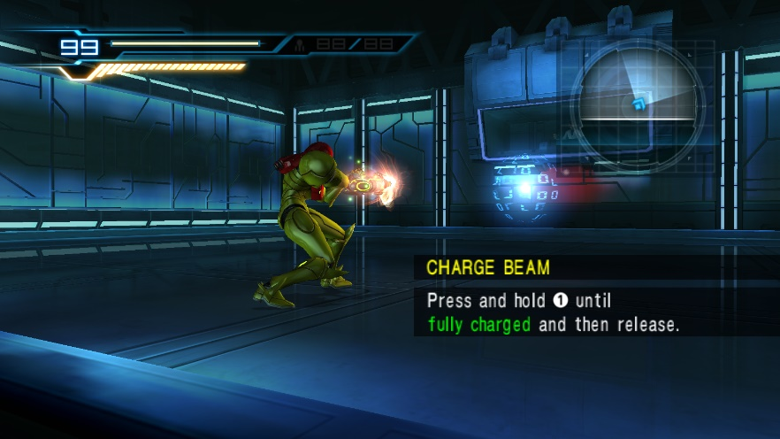
Figure 12 Metroid: Other M

Level 2: gravity
Mechanic: Gravity control
Objective: Get through the level
Obstacles: Large uncrossable gap, unmovable object, high gravity platforming
Setting: Space
Mood: Spaceship
Theme: Mastering the elements (gravity)
In the first level on the spaceship, the player must figure out a way inside.

Level 3: electric/water
Mechanic: Electric and water puzzles, levers, buttons, jump pads, heavy boxes,
Objective: Solve the testing chamber and exit the level.
Obstacles: "Broken" buildings, electricity and water, camera's, locked doors
Setting: post-apocalyptic city (Ruined)
Mood: "Old, sad, forgotten". (Just forget that it is in a testing chamber)
Theme: Ruined city
In this level, there are several objects that must be activated to complete the testing chamber. As there will be only one power source, the player must reroute the electricity to power the object that is needed to progress in the puzzle.

Level 4: illusion
Mechanics: Visual illusions, non-Euclidean rooms (Impossible rooms), levers and buttons, pressure plates, light/heavy boxes.
Objective: Solve the testing chamber and exit the level.
Obstacles: Visual illusions, camera's, locked doors, impossible rooms
Setting: Sci-fi building with a lot of wires
Mood: dark, confusing (because non-Euclidean rooms)
Theme: Sci-fi
The final level of the game uses visual illusions to challenge the player.

